6 May 2002
MEMORANDUM FOR MAJCOM EDUCATION AND TRAINING DIRECTORS
FROM: AF/DPDE
SUBJECT: Air Force Tuition Assistance (TA) Policy (Nr. 2002-08)
Public Law 106-398, signed into law on 30 Oct 00, provided discretionary authority to the Secretary of each Service to pay for all or a portion of tuition and expenses for servicemembers enrolled in college-level courses during off-duty periods.
Office of the Assistant Secretary of Defense (OASD), Force Management Policy memorandum dated 6 Nov 2001, clarified the provisions of Public Law 106-398 in terms of OASD’s Uniform TA policy and directed the Services to implement payment of higher rates effective FY 03. Subsequently, the Secretary of the Air Force approved funding of the new TA policy on 4 Apr 02.
Effective 1 Oct 02, Air Force will pay 100% of tuition costs and all fees required for enrollment, not to exceed $250.00 per semester hour with an annual cap of $4,500. TA will not be used for purchase of textbooks unless included in academic institution’s published tuition rates.
Questions regarding TA policy should be directed to Mr. Jim Sweizer, DSN 225-7321 or Ms. Marylee Baker, DSN 225-7586.
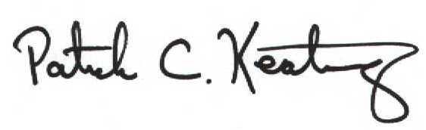
PATRICK C. KEATING, Colonel, USAF
Chief, Education Division
Directorate of Personnel Force Development

